WellPlanTM Report

Нефть Шельф
Well Name: PHS-2
Wellbore:
Design:
Case: PHS-2

Date: April 7, 2026 at 2:14 PM

Created By: edm

General Information
  - General Case Information
Company | Нефть Шельф
Project | Нагнетательная скважина | Site | МЛСП
Well | PHS-2 | Wellbore
Design |  | Case | PHS-2
Hole MD | 2680,00 m | Hole TVD | 2240,71 m
Air Gap | 35,00 m | Water Depth | 50,00 m
Reference Point | Datum #1 @ m | Well Type | Platform
  - Active Fluid

Fluid Data
Fluid | Mud #1 | Type | Mud
Mud Base Type | Brine | Base Fluid | Brine
Rheology Model | Newtonian | Foamed

Compressibility Data
Oil (Vol)/Water (Vol) | 80,00 %/20,00 % | Reference Temperature | 21,111
Salt Content (wt) | 10,00 | Average Solid Gravity | 2,000

Rheology Data
Temperature  (°C) | Pressure  (kPa) | Base Density  (kg/m³) | Ref Fluid Properties | PV (Mulnf)  (mPa*s) | Fann Data
 |  |  |  |  | Speed  (rpm) | Dial  (°)
21,111 | 101,35 | 812 | Yes | 24
  - Hole Section
Section  Type | Section Depth  (m) | Section Length  (m) | Shoe Depth  (m) | ID  (mm) | Drift  (mm) | Eff. Hole Diameter  (mm) | Coefficient  of  Friction | Linear Capacity  (L/m) | Volume  Excess  (%)
Casing | 2680 | 2680 | 2680 | 220,5 | 219,08 | 311,15 | 0,23 | 38,19
  - String Details
Type | Length  (m) | Depth  (m) | Body |  | Stabilizer / Tool Joint |  |  |  | Weight | Material | Grade | Class
 |  |  | OD  (mm) | ID  (mm) | Avg Joint Length  (m) | Length  (m) | OD  (mm) | ID  (mm)
Tubing | 2678 | 2678 | 139,7 | 124,26 |  |  |  |  | 25,3 | CS_API 5CT | L-80
Packer | 2 | 2680 | 214 | 100,5 | 2 |  |  |  | 50 | CS_API 5CT | 4145H MOD

Grade in Use
Grade | Minimum Yield Stress (kPa)
4145H MOD | 758 423
L-80 | 551 581
  - Wellpath - Calculation Method: Minimum Curvature
MD  (m) | INC  (°) | AZ  (°) | TVD  (m) | DLS  (°/30m) | AbsTort  (°/30m) | RelTort  (°/30m) | VSect  (m) | NS  (m) | EW  (m) | Build  (°/30m) | Walk  (°/30m)
0,00 | 0,00 | 0,00 | 0,00 | 0,000 | 0,000 | 0,000 | 0,00 | 0,00 | 0,00 | 0,000 | 0,000
10,00 | 0,19 | 81,81 | 10,00 | 0,570 | 0,570 | 0,000 | 0,00 | 0,00 | 0,02 | 0,570 | 0,000
20,00 | 0,37 | 81,81 | 20,00 | 0,540 | 0,555 | 0,000 | 0,01 | 0,01 | 0,06 | 0,540 | 0,000
30,00 | 0,26 | 78,26 | 30,00 | 0,335 | 0,482 | 0,000 | 0,02 | 0,02 | 0,12 | -0,330 | -10,650
40,00 | 0,20 | 54,60 | 40,00 | 0,333 | 0,445 | 0,000 | 0,03 | 0,03 | 0,16 | -0,180 | -70,980
50,00 | 0,18 | 32,69 | 50,00 | 0,225 | 0,401 | 0,000 | 0,06 | 0,06 | 0,18 | -0,060 | -65,730
60,00 | 0,25 | 359,14 | 60,00 | 0,423 | 0,404 | 0,000 | 0,09 | 0,09 | 0,19 | 0,210 | -100,650
61,78 | 0,25 | 355,90 | 61,78 | 0,238 | 0,400 | 0,000 | 0,10 | 0,10 | 0,19 | 0,000 | -54,607
70,00 | 0,27 | 341,94 | 70,00 | 0,242 | 0,381 | 0,000 | 0,14 | 0,14 | 0,18 | 0,073 | -50,949
80,00 | 0,34 | 335,40 | 80,00 | 0,234 | 0,363 | 0,000 | 0,19 | 0,19 | 0,16 | 0,210 | -19,620
90,00 | 0,41 | 328,70 | 90,00 | 0,247 | 0,350 | 0,000 | 0,24 | 0,24 | 0,13 | 0,210 | -20,100
100,00 | 0,45 | 97,36 | 100,00 | 2,326 | 0,547 | 0,000 | 0,27 | 0,27 | 0,15 | 0,120 | 385,980
110,00 | 0,46 | 73,74 | 110,00 | 0,560 | 0,549 | 0,000 | 0,27 | 0,27 | 0,23 | 0,030 | -70,860
120,00 | 0,47 | 39,33 | 120,00 | 0,826 | 0,572 | 0,000 | 0,32 | 0,32 | 0,29 | 0,030 | -103,230
130,00 | 0,30 | 102,75 | 130,00 | 1,289 | 0,627 | 0,000 | 0,34 | 0,34 | 0,34 | -0,510 | 190,260
140,00 | 0,35 | 129,94 | 140,00 | 0,481 | 0,616 | 0,000 | 0,32 | 0,32 | 0,39 | 0,150 | 81,570
150,00 | 0,48 | 143,29 | 150,00 | 0,484 | 0,608 | 0,000 | 0,26 | 0,26 | 0,44 | 0,390 | 40,050
160,00 | 0,74 | 129,76 | 160,00 | 0,886 | 0,625 | 0,000 | 0,19 | 0,19 | 0,51 | 0,780 | -40,590
170,00 | 0,68 | 119,50 | 170,00 | 0,421 | 0,613 | 0,000 | 0,12 | 0,12 | 0,62 | -0,180 | -30,780
180,00 | 1,05 | 97,93 | 180,00 | 1,460 | 0,660 | 0,000 | 0,08 | 0,08 | 0,76 | 1,110 | -64,710
190,00 | 0,33 | 148,13 | 189,99 | 2,629 | 0,764 | 0,000 | 0,04 | 0,04 | 0,86 | -2,160 | 150,600
200,00 | 0,14 | 212,60 | 199,99 | 0,893 | 0,770 | 0,000 | 0,01 | 0,01 | 0,87 | -0,570 | 193,410
210,00 | 0,16 | 298,60 | 209,99 | 0,615 | 0,763 | 0,000 | 0,00 | 0,00 | 0,85 | 0,060 | 258,000
220,00 | 0,27 | 21,82 | 219,99 | 0,891 | 0,769 | 0,000 | 0,03 | 0,03 | 0,85 | 0,330 | 249,660
230,00 | 0,23 | 353,36 | 229,99 | 0,387 | 0,752 | 0,000 | 0,07 | 0,07 | 0,86 | -0,120 | -85,380
240,00 | 0,76 | 224,80 | 239,99 | 2,763 | 0,836 | 0,000 | 0,05 | 0,05 | 0,81 | 1,590 | -385,680
250,00 | 1,31 | 223,18 | 249,99 | 1,652 | 0,869 | 0,000 | -0,09 | -0,09 | 0,68 | 1,650 | -4,860
260,00 | 2,08 | 217,20 | 259,99 | 2,367 | 0,926 | 0,000 | -0,31 | -0,31 | 0,49 | 2,310 | -17,940
270,00 | 3,23 | 211,19 | 269,98 | 3,545 | 1,023 | 0,000 | -0,70 | -0,70 | 0,24 | 3,450 | -18,030
280,00 | 4,39 | 208,34 | 279,95 | 3,525 | 1,112 | 0,000 | -1,28 | -1,28 | -0,09 | 3,480 | -8,550
290,00 | 4,63 | 204,87 | 289,92 | 1,090 | 1,112 | 0,000 | -1,98 | -1,98 | -0,44 | 0,720 | -10,410
300,00 | 4,88 | 201,74 | 299,89 | 1,081 | 1,111 | 0,000 | -2,74 | -2,74 | -0,77 | 0,750 | -9,390
310,00 | 5,79 | 197,46 | 309,85 | 2,978 | 1,171 | 0,000 | -3,62 | -3,62 | -1,08 | 2,730 | -12,840
320,00 | 6,73 | 194,35 | 319,79 | 2,997 | 1,228 | 0,000 | -4,67 | -4,67 | -1,37 | 2,820 | -9,330
330,00 | 7,22 | 190,41 | 329,71 | 2,054 | 1,253 | 0,000 | -5,85 | -5,85 | -1,63 | 1,470 | -11,820
340,00 | 7,74 | 186,99 | 339,63 | 2,053 | 1,277 | 0,000 | -7,14 | -7,14 | -1,83 | 1,560 | -10,260
350,00 | 8,29 | 184,00 | 349,53 | 2,070 | 1,299 | 0,000 | -8,53 | -8,53 | -1,96 | 1,650 | -8,970
355,89 | 8,62 | 182,42 | 355,36 | 2,055 | 1,312 | 0,000 | -9,39 | -9,39 | -2,01 | 1,681 | -8,048
360,00 | 9,09 | 182,14 | 359,42 | 3,445 | 1,336 | 0,000 | -10,02 | -10,02 | -2,03 | 3,431 | -2,044
370,00 | 10,23 | 181,57 | 369,27 | 3,432 | 1,393 | 0,000 | -11,70 | -11,70 | -2,09 | 3,420 | -1,710
380,00 | 11,37 | 181,11 | 379,10 | 3,430 | 1,446 | 0,000 | -13,57 | -13,57 | -2,13 | 3,420 | -1,380
384,37 | 11,87 | 180,94 | 383,38 | 3,441 | 1,469 | 0,000 | -14,45 | -14,45 | -2,15 | 3,432 | -1,167
390,00 | 12,00 | 180,95 | 388,89 | 0,693 | 1,458 | 0,000 | -15,62 | -15,62 | -2,17 | 0,693 | 0,053
400,00 | 12,22 | 180,96 | 398,66 | 0,660 | 1,438 | 0,000 | -17,71 | -17,71 | -2,20 | 0,660 | 0,030
410,00 | 12,44 | 180,98 | 408,43 | 0,660 | 1,419 | 0,000 | -19,85 | -19,85 | -2,24 | 0,660 | 0,060
412,21 | 12,49 | 180,98 | 410,59 | 0,679 | 1,415 | 0,000 | -20,33 | -20,33 | -2,24 | 0,679 | 0,000
420,00 | 13,39 | 181,85 | 418,18 | 3,546 | 1,454 | 0,000 | -22,07 | -22,07 | -2,29 | 3,466 | 3,350
430,00 | 14,54 | 182,81 | 427,89 | 3,519 | 1,502 | 0,000 | -24,48 | -24,48 | -2,39 | 3,450 | 2,880
440,00 | 15,70 | 183,63 | 437,54 | 3,539 | 1,549 | 0,000 | -27,09 | -27,09 | -2,53 | 3,480 | 2,460
440,77 | 15,79 | 183,69 | 438,28 | 3,563 | 1,552 | 0,000 | -27,29 | -27,29 | -2,55 | 3,506 | 2,338
450,00 | 16,87 | 182,19 | 447,14 | 3,768 | 1,598 | 0,000 | -29,89 | -29,89 | -2,68 | 3,510 | -4,875
460,00 | 18,04 | 180,76 | 456,68 | 3,738 | 1,644 | 0,000 | -32,88 | -32,88 | -2,76 | 3,510 | -4,290
469,35 | 19,15 | 179,58 | 465,54 | 3,760 | 1,686 | 0,000 | -35,87 | -35,87 | -2,76 | 3,562 | -3,786
470,00 | 19,21 | 179,53 | 466,15 | 2,871 | 1,688 | 0,000 | -36,08 | -36,08 | -2,76 | 2,769 | -2,308
478,70 | 20,04 | 178,90 | 474,35 | 2,954 | 1,711 | 0,000 | -39,00 | -39,00 | -2,72 | 2,862 | -2,172
480,00 | 20,16 | 178,81 | 475,57 | 2,860 | 1,714 | 0,000 | -39,45 | -39,45 | -2,71 | 2,769 | -2,077
490,00 | 21,12 | 178,15 | 484,93 | 2,963 | 1,740 | 0,000 | -42,97 | -42,97 | -2,62 | 2,880 | -1,980
500,00 | 22,07 | 177,55 | 494,23 | 2,926 | 1,763 | 0,000 | -46,65 | -46,65 | -2,48 | 2,850 | -1,800
500,83 | 22,15 | 177,50 | 494,99 | 2,971 | 1,765 | 0,000 | -46,96 | -46,96 | -2,47 | 2,892 | -1,807
510,00 | 22,02 | 178,04 | 503,49 | 0,789 | 1,748 | 0,000 | -50,41 | -50,41 | -2,33 | -0,425 | 1,767
520,00 | 21,87 | 178,63 | 512,77 | 0,800 | 1,730 | 0,000 | -54,14 | -54,14 | -2,22 | -0,450 | 1,770
528,58 | 21,75 | 179,15 | 520,73 | 0,795 | 1,714 | 0,000 | -57,33 | -57,33 | -2,16 | -0,420 | 1,818
530,00 | 21,86 | 179,25 | 522,05 | 2,453 | 1,716 | 0,000 | -57,86 | -57,86 | -2,15 | 2,324 | 2,113
540,00 | 22,65 | 179,94 | 531,31 | 2,496 | 1,731 | 0,000 | -61,64 | -61,64 | -2,13 | 2,370 | 2,070
550,00 | 23,44 | 180,59 | 540,51 | 2,490 | 1,745 | 0,000 | -65,56 | -65,56 | -2,15 | 2,370 | 1,950
556,80 | 23,98 | 181,01 | 546,73 | 2,496 | 1,754 | 0,000 | -68,29 | -68,29 | -2,18 | 2,382 | 1,853
560,00 | 24,28 | 181,18 | 549,66 | 2,887 | 1,760 | 0,000 | -69,60 | -69,60 | -2,21 | 2,813 | 1,594
570,00 | 25,21 | 181,69 | 558,74 | 2,863 | 1,780 | 0,000 | -73,78 | -73,78 | -2,31 | 2,790 | 1,530
580,00 | 26,14 | 182,17 | 567,75 | 2,859 | 1,798 | 0,000 | -78,11 | -78,11 | -2,46 | 2,790 | 1,440
585,06 | 26,61 | 182,40 | 572,28 | 2,852 | 1,807 | 0,000 | -80,36 | -80,36 | -2,55 | 2,787 | 1,364
590,00 | 27,18 | 182,20 | 576,69 | 3,505 | 1,822 | 0,000 | -82,59 | -82,59 | -2,64 | 3,462 | -1,215
600,00 | 28,35 | 181,82 | 585,54 | 3,550 | 1,850 | 0,000 | -87,25 | -87,25 | -2,80 | 3,510 | -1,140
610,00 | 29,51 | 181,47 | 594,29 | 3,517 | 1,878 | 0,000 | -92,08 | -92,08 | -2,94 | 3,480 | -1,050
613,08 | 29,87 | 181,37 | 596,96 | 3,540 | 1,886 | 0,000 | -93,61 | -93,61 | -2,98 | 3,506 | -0,974
620,00 | 30,15 | 181,02 | 602,96 | 1,432 | 1,881 | 0,000 | -97,07 | -97,07 | -3,05 | 1,214 | -1,517
630,00 | 30,57 | 180,53 | 611,59 | 1,463 | 1,874 | 0,000 | -102,12 | -102,12 | -3,12 | 1,260 | -1,470
640,00 | 30,98 | 180,05 | 620,18 | 1,434 | 1,867 | 0,000 | -107,24 | -107,24 | -3,15 | 1,230 | -1,440
641,18 | 31,03 | 179,99 | 621,19 | 1,494 | 1,867 | 0,000 | -107,85 | -107,85 | -3,15 | 1,271 | -1,525
650,00 | 30,99 | 180,18 | 628,75 | 0,360 | 1,846 | 0,000 | -112,39 | -112,39 | -3,15 | -0,136 | 0,646
660,00 | 30,94 | 180,40 | 637,32 | 0,371 | 1,824 | 0,000 | -117,54 | -117,54 | -3,18 | -0,150 | 0,660
669,30 | 30,90 | 180,60 | 645,30 | 0,356 | 1,804 | 0,000 | -122,31 | -122,31 | -3,22 | -0,129 | 0,645
670,00 | 30,92 | 180,60 | 645,90 | 0,857 | 1,803 | 0,000 | -122,67 | -122,67 | -3,22 | 0,857 | 0,000
680,00 | 31,15 | 180,55 | 654,47 | 0,694 | 1,786 | 0,000 | -127,83 | -127,83 | -3,28 | 0,690 | -0,150
690,00 | 31,38 | 180,51 | 663,02 | 0,693 | 1,770 | 0,000 | -133,02 | -133,02 | -3,32 | 0,690 | -0,120
697,60 | 31,56 | 180,48 | 669,50 | 0,713 | 1,759 | 0,000 | -136,99 | -136,99 | -3,36 | 0,711 | -0,118
700,00 | 31,70 | 180,29 | 671,54 | 2,148 | 1,760 | 0,000 | -138,25 | -138,25 | -3,37 | 1,750 | -2,375
710,00 | 32,26 | 179,51 | 680,03 | 2,088 | 1,765 | 0,000 | -143,54 | -143,54 | -3,36 | 1,680 | -2,340
720,00 | 32,84 | 178,75 | 688,46 | 2,129 | 1,770 | 0,000 | -148,92 | -148,92 | -3,28 | 1,740 | -2,280
726,11 | 33,19 | 178,30 | 693,58 | 2,098 | 1,773 | 0,000 | -152,25 | -152,25 | -3,19 | 1,718 | -2,209
730,00 | 33,31 | 178,43 | 696,83 | 1,076 | 1,769 | 0,000 | -154,38 | -154,38 | -3,13 | 0,925 | 1,003
740,00 | 33,61 | 178,76 | 705,17 | 1,053 | 1,759 | 0,000 | -159,89 | -159,89 | -2,99 | 0,900 | 0,990
750,00 | 33,91 | 179,08 | 713,49 | 1,046 | 1,750 | 0,000 | -165,45 | -165,45 | -2,89 | 0,900 | 0,960
754,51 | 34,05 | 179,22 | 717,23 | 1,067 | 1,746 | 0,000 | -167,97 | -167,97 | -2,85 | 0,931 | 0,931
760,00 | 34,32 | 178,74 | 721,77 | 2,085 | 1,748 | 0,000 | -171,05 | -171,05 | -2,80 | 1,475 | -2,623
770,00 | 34,82 | 177,90 | 730,00 | 2,072 | 1,752 | 0,000 | -176,73 | -176,73 | -2,63 | 1,500 | -2,520
780,00 | 35,32 | 177,07 | 738,19 | 2,073 | 1,756 | 0,000 | -182,47 | -182,47 | -2,38 | 1,500 | -2,490
781,44 | 35,39 | 176,95 | 739,36 | 2,054 | 1,757 | 0,000 | -183,30 | -183,30 | -2,33 | 1,458 | -2,500
790,00 | 35,83 | 176,60 | 746,32 | 1,699 | 1,756 | 0,000 | -188,27 | -188,27 | -2,05 | 1,542 | -1,227
800,00 | 36,34 | 176,20 | 754,40 | 1,685 | 1,755 | 0,000 | -194,15 | -194,15 | -1,68 | 1,530 | -1,200
808,88 | 36,79 | 175,86 | 761,54 | 1,667 | 1,755 | 0,000 | -199,43 | -199,43 | -1,32 | 1,520 | -1,149
810,00 | 36,86 | 175,88 | 762,43 | 1,902 | 1,755 | 0,000 | -200,10 | -200,10 | -1,27 | 1,875 | 0,536
820,00 | 37,44 | 176,05 | 770,40 | 1,767 | 1,755 | 0,000 | -206,12 | -206,12 | -0,84 | 1,740 | 0,510
830,00 | 38,02 | 176,22 | 778,31 | 1,768 | 1,755 | 0,000 | -212,23 | -212,23 | -0,43 | 1,740 | 0,510
837,92 | 38,48 | 176,35 | 784,53 | 1,769 | 1,755 | 0,000 | -217,12 | -217,12 | -0,11 | 1,742 | 0,492
840,00 | 38,47 | 176,30 | 786,16 | 0,471 | 1,752 | 0,000 | -218,41 | -218,41 | -0,03 | -0,144 | -0,721
850,00 | 38,41 | 176,04 | 793,99 | 0,517 | 1,737 | 0,000 | -224,62 | -224,62 | 0,38 | -0,180 | -0,780
860,00 | 38,35 | 175,79 | 801,83 | 0,499 | 1,723 | 0,000 | -230,81 | -230,81 | 0,83 | -0,180 | -0,750
865,92 | 38,32 | 175,64 | 806,48 | 0,495 | 1,715 | 0,000 | -234,47 | -234,47 | 1,10 | -0,152 | -0,760
870,00 | 38,30 | 175,83 | 809,68 | 0,878 | 1,711 | 0,000 | -236,99 | -236,99 | 1,29 | -0,147 | 1,397
880,00 | 38,25 | 176,29 | 817,53 | 0,868 | 1,701 | 0,000 | -243,17 | -243,17 | 1,71 | -0,150 | 1,380
890,00 | 38,20 | 176,76 | 825,38 | 0,885 | 1,692 | 0,000 | -249,35 | -249,35 | 2,09 | -0,150 | 1,410
893,88 | 38,18 | 176,94 | 828,43 | 0,874 | 1,688 | 0,000 | -251,74 | -251,74 | 2,22 | -0,155 | 1,392
900,00 | 38,20 | 177,22 | 833,24 | 0,854 | 1,683 | 0,000 | -255,52 | -255,52 | 2,41 | 0,098 | 1,373
910,00 | 38,24 | 177,67 | 841,10 | 0,844 | 1,674 | 0,000 | -261,70 | -261,70 | 2,69 | 0,120 | 1,350
920,00 | 38,28 | 178,13 | 848,95 | 0,863 | 1,665 | 0,000 | -267,89 | -267,89 | 2,92 | 0,120 | 1,380
922,05 | 38,29 | 178,22 | 850,56 | 0,829 | 1,663 | 0,000 | -269,16 | -269,16 | 2,96 | 0,146 | 1,317
930,00 | 38,29 | 178,67 | 856,80 | 1,052 | 1,658 | 0,000 | -274,09 | -274,09 | 3,09 | 0,000 | 1,698
940,00 | 38,30 | 179,23 | 864,65 | 1,042 | 1,651 | 0,000 | -280,28 | -280,28 | 3,20 | 0,030 | 1,680
950,00 | 38,31 | 179,79 | 872,50 | 1,042 | 1,645 | 0,000 | -286,48 | -286,48 | 3,26 | 0,030 | 1,680
950,85 | 38,31 | 179,84 | 873,16 | 1,094 | 1,644 | 0,000 | -287,01 | -287,01 | 3,26 | 0,000 | 1,765
960,00 | 38,23 | 180,39 | 880,35 | 1,147 | 1,639 | 0,000 | -292,67 | -292,67 | 3,25 | -0,262 | 1,803
970,00 | 38,15 | 180,99 | 888,21 | 1,138 | 1,634 | 0,000 | -298,86 | -298,86 | 3,17 | -0,240 | 1,800
979,02 | 38,08 | 181,54 | 895,30 | 1,153 | 1,630 | 0,000 | -304,42 | -304,42 | 3,05 | -0,233 | 1,829
980,00 | 38,06 | 181,57 | 896,07 | 0,834 | 1,629 | 0,000 | -305,03 | -305,03 | 3,03 | -0,612 | 0,918
990,00 | 37,88 | 181,82 | 903,96 | 0,710 | 1,620 | 0,000 | -311,18 | -311,18 | 2,85 | -0,540 | 0,750
1000,00 | 37,71 | 182,08 | 911,86 | 0,699 | 1,611 | 0,000 | -317,30 | -317,30 | 2,64 | -0,510 | 0,780
1007,21 | 37,58 | 182,27 | 917,57 | 0,725 | 1,604 | 0,000 | -321,70 | -321,70 | 2,48 | -0,541 | 0,791
1010,00 | 37,54 | 182,36 | 919,78 | 0,730 | 1,602 | 0,000 | -323,40 | -323,40 | 2,41 | -0,430 | 0,968
1020,00 | 37,40 | 182,67 | 927,72 | 0,705 | 1,593 | 0,000 | -329,48 | -329,48 | 2,14 | -0,420 | 0,930
1030,00 | 37,26 | 182,99 | 935,67 | 0,718 | 1,585 | 0,000 | -335,53 | -335,53 | 1,84 | -0,420 | 0,960
1035,45 | 37,19 | 183,16 | 940,01 | 0,685 | 1,580 | 0,000 | -338,83 | -338,83 | 1,66 | -0,385 | 0,936
1040,00 | 37,17 | 183,30 | 943,63 | 0,573 | 1,575 | 0,000 | -341,57 | -341,57 | 1,51 | -0,132 | 0,923
1050,00 | 37,11 | 183,62 | 951,61 | 0,607 | 1,566 | 0,000 | -347,60 | -347,60 | 1,15 | -0,180 | 0,960
1060,00 | 37,06 | 183,93 | 959,58 | 0,581 | 1,557 | 0,000 | -353,62 | -353,62 | 0,75 | -0,150 | 0,930
1063,85 | 37,04 | 184,05 | 962,66 | 0,585 | 1,553 | 0,000 | -355,93 | -355,93 | 0,59 | -0,156 | 0,935
1070,00 | 37,05 | 184,07 | 967,56 | 0,076 | 1,545 | 0,000 | -359,63 | -359,63 | 0,32 | 0,049 | 0,098
1080,00 | 37,06 | 184,09 | 975,54 | 0,047 | 1,531 | 0,000 | -365,64 | -365,64 | -0,10 | 0,030 | 0,060
1090,00 | 37,08 | 184,12 | 983,52 | 0,081 | 1,518 | 0,000 | -371,65 | -371,65 | -0,54 | 0,060 | 0,090
1091,61 | 37,08 | 184,12 | 984,81 | 0,000 | 1,515 | 0,000 | -372,62 | -372,62 | -0,61 | 0,000 | 0,000
1100,00 | 37,09 | 183,52 | 991,50 | 1,294 | 1,514 | 0,000 | -377,66 | -377,66 | -0,94 | 0,036 | -2,145
1110,00 | 37,10 | 182,82 | 999,48 | 1,267 | 1,512 | 0,000 | -383,69 | -383,69 | -1,28 | 0,030 | -2,100
1119,95 | 37,11 | 182,11 | 1007,41 | 1,292 | 1,510 | 0,000 | -389,68 | -389,68 | -1,53 | 0,030 | -2,141
1120,00 | 37,11 | 182,11 | 1007,45 | 0,000 | 1,510 | 0,000 | -389,71 | -389,71 | -1,54 | 0,000 | 0,000
1130,00 | 37,15 | 181,83 | 1015,43 | 0,521 | 1,501 | 0,000 | -395,75 | -395,75 | -1,74 | 0,120 | -0,840
1140,00 | 37,19 | 181,54 | 1023,39 | 0,539 | 1,492 | 0,000 | -401,79 | -401,79 | -1,92 | 0,120 | -0,870
1147,93 | 37,22 | 181,32 | 1029,71 | 0,516 | 1,486 | 0,000 | -406,58 | -406,58 | -2,04 | 0,113 | -0,832
1150,00 | 37,22 | 181,43 | 1031,36 | 0,964 | 1,485 | 0,000 | -407,83 | -407,83 | -2,07 | 0,000 | 1,594
1160,00 | 37,24 | 181,93 | 1039,32 | 0,910 | 1,480 | 0,000 | -413,88 | -413,88 | -2,25 | 0,060 | 1,500
1170,00 | 37,27 | 182,44 | 1047,28 | 0,931 | 1,475 | 0,000 | -419,93 | -419,93 | -2,48 | 0,090 | 1,530
1176,03 | 37,28 | 182,75 | 1052,08 | 0,935 | 1,472 | 0,000 | -423,58 | -423,58 | -2,64 | 0,050 | 1,542
1180,00 | 37,28 | 182,71 | 1055,24 | 0,183 | 1,468 | 0,000 | -425,98 | -425,98 | -2,76 | 0,000 | -0,302
1190,00 | 37,28 | 182,60 | 1063,19 | 0,200 | 1,457 | 0,000 | -432,03 | -432,03 | -3,04 | 0,000 | -0,330
1200,00 | 37,29 | 182,50 | 1071,15 | 0,184 | 1,447 | 0,000 | -438,08 | -438,08 | -3,31 | 0,030 | -0,300
1204,37 | 37,29 | 182,45 | 1074,63 | 0,208 | 1,442 | 0,000 | -440,72 | -440,72 | -3,42 | 0,000 | -0,343
1210,00 | 37,28 | 182,32 | 1079,11 | 0,423 | 1,437 | 0,000 | -444,13 | -444,13 | -3,56 | -0,053 | -0,693
1220,00 | 37,25 | 182,10 | 1087,06 | 0,410 | 1,429 | 0,000 | -450,18 | -450,18 | -3,80 | -0,090 | -0,660
1230,00 | 37,23 | 181,87 | 1095,03 | 0,422 | 1,421 | 0,000 | -456,23 | -456,23 | -4,01 | -0,060 | -0,690
1232,63 | 37,22 | 181,81 | 1097,12 | 0,429 | 1,419 | 0,000 | -457,82 | -457,82 | -4,06 | -0,114 | -0,684
1240,00 | 36,86 | 182,43 | 1103,00 | 2,112 | 1,423 | 0,000 | -462,26 | -462,26 | -4,22 | -1,465 | 2,524
1250,00 | 36,38 | 183,28 | 1111,03 | 2,095 | 1,428 | 0,000 | -468,22 | -468,22 | -4,52 | -1,440 | 2,550
1260,00 | 35,91 | 184,15 | 1119,10 | 2,088 | 1,433 | 0,000 | -474,10 | -474,10 | -4,90 | -1,410 | 2,610
1260,68 | 35,88 | 184,21 | 1119,66 | 2,040 | 1,434 | 0,000 | -474,50 | -474,50 | -4,93 | -1,324 | 2,647
1270,00 | 35,66 | 184,96 | 1127,22 | 1,579 | 1,435 | 0,000 | -479,93 | -479,93 | -5,37 | -0,708 | 2,414
1280,00 | 35,42 | 185,77 | 1135,35 | 1,585 | 1,436 | 0,000 | -485,72 | -485,72 | -5,91 | -0,720 | 2,430
1288,67 | 35,22 | 186,48 | 1142,43 | 1,580 | 1,437 | 0,000 | -490,70 | -490,70 | -6,44 | -0,692 | 2,457
1290,00 | 35,19 | 186,59 | 1143,52 | 1,582 | 1,437 | 0,000 | -491,46 | -491,46 | -6,53 | -0,677 | 2,481
1300,00 | 34,97 | 187,43 | 1151,70 | 1,592 | 1,438 | 0,000 | -497,17 | -497,17 | -7,23 | -0,660 | 2,520
1310,00 | 34,75 | 188,28 | 1159,90 | 1,600 | 1,440 | 0,000 | -502,83 | -502,83 | -8,01 | -0,660 | 2,550
1317,07 | 34,60 | 188,89 | 1165,72 | 1,604 | 1,440 | 0,000 | -506,80 | -506,80 | -8,61 | -0,636 | 2,588
1320,00 | 34,58 | 188,89 | 1168,13 | 0,205 | 1,438 | 0,000 | -508,45 | -508,45 | -8,87 | -0,205 | 0,000
1330,00 | 34,50 | 188,89 | 1176,37 | 0,240 | 1,429 | 0,000 | -514,05 | -514,05 | -9,75 | -0,240 | 0,000
1340,00 | 34,42 | 188,90 | 1184,61 | 0,241 | 1,420 | 0,000 | -519,64 | -519,64 | -10,62 | -0,240 | 0,030
1345,06 | 34,38 | 188,90 | 1188,79 | 0,237 | 1,415 | 0,000 | -522,46 | -522,46 | -11,06 | -0,237 | 0,000
1350,00 | 34,34 | 189,11 | 1192,87 | 0,760 | 1,413 | 0,000 | -525,22 | -525,22 | -11,50 | -0,243 | 1,275
1360,00 | 34,25 | 189,52 | 1201,13 | 0,744 | 1,408 | 0,000 | -530,78 | -530,78 | -12,41 | -0,270 | 1,230
1370,00 | 34,17 | 189,94 | 1209,40 | 0,748 | 1,403 | 0,000 | -536,32 | -536,32 | -13,36 | -0,240 | 1,260
1373,49 | 34,14 | 190,09 | 1212,29 | 0,768 | 1,402 | 0,000 | -538,25 | -538,25 | -13,70 | -0,258 | 1,289
1380,00 | 33,87 | 190,16 | 1217,68 | 1,257 | 1,401 | 0,000 | -541,83 | -541,83 | -14,34 | -1,244 | 0,323
1390,00 | 33,44 | 190,26 | 1226,01 | 1,301 | 1,400 | 0,000 | -547,29 | -547,29 | -15,33 | -1,290 | 0,300
1400,00 | 33,02 | 190,36 | 1234,37 | 1,271 | 1,399 | 0,000 | -552,68 | -552,68 | -16,31 | -1,260 | 0,300
1401,74 | 32,95 | 190,38 | 1235,83 | 1,221 | 1,399 | 0,000 | -553,61 | -553,61 | -16,48 | -1,207 | 0,345
1410,00 | 32,61 | 191,08 | 1242,78 | 1,849 | 1,402 | 0,000 | -558,00 | -558,00 | -17,31 | -1,235 | 2,542
1420,00 | 32,21 | 191,95 | 1251,22 | 1,843 | 1,405 | 0,000 | -563,26 | -563,26 | -18,38 | -1,200 | 2,610
1429,90 | 31,82 | 192,83 | 1259,61 | 1,843 | 1,408 | 0,000 | -568,38 | -568,38 | -19,51 | -1,182 | 2,667
1430,00 | 31,81 | 192,84 | 1259,70 | 3,391 | 1,408 | 0,000 | -568,43 | -568,43 | -19,52 | -3,000 | 3,000
1440,00 | 31,29 | 193,76 | 1268,22 | 2,126 | 1,413 | 0,000 | -573,53 | -573,53 | -20,72 | -1,560 | 2,760
1450,00 | 30,78 | 194,71 | 1276,79 | 2,121 | 1,418 | 0,000 | -578,52 | -578,52 | -21,99 | -1,530 | 2,850
1457,96 | 30,37 | 195,48 | 1283,64 | 2,137 | 1,422 | 0,000 | -582,43 | -582,43 | -23,04 | -1,545 | 2,902
1460,00 | 30,28 | 195,59 | 1285,40 | 1,555 | 1,422 | 0,000 | -583,42 | -583,42 | -23,32 | -1,324 | 1,618
1470,00 | 29,82 | 196,13 | 1294,06 | 1,601 | 1,423 | 0,000 | -588,24 | -588,24 | -24,69 | -1,380 | 1,620
1480,00 | 29,36 | 196,69 | 1302,75 | 1,610 | 1,424 | 0,000 | -592,98 | -592,98 | -26,08 | -1,380 | 1,680
1486,06 | 29,09 | 197,04 | 1308,04 | 1,582 | 1,425 | 0,000 | -595,81 | -595,81 | -26,94 | -1,337 | 1,733
1490,00 | 28,92 | 197,47 | 1311,49 | 2,048 | 1,427 | 0,000 | -597,63 | -597,63 | -27,51 | -1,294 | 3,274
1500,00 | 28,48 | 198,60 | 1320,26 | 2,096 | 1,431 | 0,000 | -602,20 | -602,20 | -28,99 | -1,320 | 3,390
1510,00 | 28,05 | 199,76 | 1329,07 | 2,093 | 1,436 | 0,000 | -606,67 | -606,67 | -30,55 | -1,290 | 3,480
1514,53 | 27,86 | 200,29 | 1333,07 | 2,071 | 1,437 | 0,000 | -608,67 | -608,67 | -31,28 | -1,258 | 3,510
1520,00 | 27,70 | 201,03 | 1337,91 | 2,085 | 1,440 | 0,000 | -611,05 | -611,05 | -32,17 | -0,878 | 4,059
1530,00 | 27,43 | 202,41 | 1346,77 | 2,080 | 1,444 | 0,000 | -615,35 | -615,35 | -33,89 | -0,810 | 4,140
1540,00 | 27,16 | 203,81 | 1355,66 | 2,089 | 1,448 | 0,000 | -619,57 | -619,57 | -35,69 | -0,810 | 4,200
1542,89 | 27,09 | 204,22 | 1358,23 | 2,072 | 1,449 | 0,000 | -620,77 | -620,77 | -36,22 | -0,727 | 4,256
1550,00 | 26,85 | 205,12 | 1364,57 | 1,998 | 1,452 | 0,000 | -623,70 | -623,70 | -37,57 | -1,013 | 3,797
1560,00 | 26,53 | 206,41 | 1373,50 | 1,986 | 1,455 | 0,000 | -627,75 | -627,75 | -39,52 | -0,960 | 3,870
1570,00 | 26,22 | 207,73 | 1382,46 | 1,990 | 1,459 | 0,000 | -631,70 | -631,70 | -41,54 | -0,930 | 3,960
1571,07 | 26,19 | 207,87 | 1383,42 | 1,927 | 1,459 | 0,000 | -632,12 | -632,12 | -41,76 | -0,841 | 3,925
1580,00 | 25,82 | 209,48 | 1391,45 | 2,677 | 1,466 | 0,000 | -635,56 | -635,56 | -43,64 | -1,243 | 5,409
1590,00 | 25,43 | 211,33 | 1400,46 | 2,670 | 1,473 | 0,000 | -639,29 | -639,29 | -45,83 | -1,170 | 5,550
1599,23 | 25,09 | 213,08 | 1408,81 | 2,667 | 1,480 | 0,000 | -642,62 | -642,62 | -47,93 | -1,105 | 5,688
1600,00 | 25,08 | 213,21 | 1409,51 | 2,182 | 1,481 | 0,000 | -642,89 | -642,89 | -48,11 | -0,390 | 5,065
1610,00 | 24,96 | 214,92 | 1418,57 | 2,199 | 1,485 | 0,000 | -646,40 | -646,40 | -50,47 | -0,360 | 5,130
1620,00 | 24,85 | 216,64 | 1427,64 | 2,198 | 1,490 | 0,000 | -649,81 | -649,81 | -52,94 | -0,330 | 5,160
1627,47 | 24,79 | 217,93 | 1434,42 | 2,188 | 1,493 | 0,000 | -652,31 | -652,31 | -54,84 | -0,241 | 5,181
1630,00 | 24,77 | 218,29 | 1436,72 | 1,805 | 1,493 | 0,000 | -653,14 | -653,14 | -55,49 | -0,237 | 4,269
1640,00 | 24,69 | 219,70 | 1445,80 | 1,786 | 1,495 | 0,000 | -656,39 | -656,39 | -58,12 | -0,240 | 4,230
1650,00 | 24,62 | 221,11 | 1454,89 | 1,777 | 1,497 | 0,000 | -659,57 | -659,57 | -60,83 | -0,210 | 4,230
1655,46 | 24,59 | 221,89 | 1459,85 | 1,792 | 1,498 | 0,000 | -661,27 | -661,27 | -62,33 | -0,165 | 4,286
1660,00 | 24,50 | 222,55 | 1463,98 | 1,907 | 1,499 | 0,000 | -662,67 | -662,67 | -63,60 | -0,595 | 4,361
1670,00 | 24,30 | 224,03 | 1473,09 | 1,930 | 1,501 | 0,000 | -665,68 | -665,68 | -66,43 | -0,600 | 4,440
1680,00 | 24,11 | 225,53 | 1482,21 | 1,931 | 1,504 | 0,000 | -668,59 | -668,59 | -69,32 | -0,570 | 4,500
1683,68 | 24,05 | 226,09 | 1485,57 | 1,926 | 1,505 | 0,000 | -669,63 | -669,63 | -70,40 | -0,489 | 4,565
1690,00 | 23,92 | 226,74 | 1491,35 | 1,398 | 1,504 | 0,000 | -671,40 | -671,40 | -72,26 | -0,617 | 3,085
1700,00 | 23,73 | 227,77 | 1500,49 | 1,372 | 1,504 | 0,000 | -674,15 | -674,15 | -75,22 | -0,570 | 3,090
1710,00 | 23,54 | 228,83 | 1509,65 | 1,396 | 1,503 | 0,000 | -676,81 | -676,81 | -78,22 | -0,570 | 3,180
1711,93 | 23,50 | 229,03 | 1511,42 | 1,388 | 1,503 | 0,000 | -677,32 | -677,32 | -78,80 | -0,622 | 3,109
1720,00 | 23,39 | 230,39 | 1518,83 | 2,053 | 1,506 | 0,000 | -679,39 | -679,39 | -81,25 | -0,409 | 5,056
1730,00 | 23,28 | 232,10 | 1528,01 | 2,059 | 1,509 | 0,000 | -681,87 | -681,87 | -84,33 | -0,330 | 5,130
1740,00 | 23,18 | 233,81 | 1537,20 | 2,045 | 1,512 | 0,000 | -684,25 | -684,25 | -87,48 | -0,300 | 5,130
1740,33 | 23,18 | 233,87 | 1537,50 | 2,147 | 1,512 | 0,000 | -684,33 | -684,33 | -87,59 | 0,000 | 5,455
1750,00 | 23,17 | 235,33 | 1546,39 | 1,783 | 1,513 | 0,000 | -686,53 | -686,53 | -90,69 | -0,031 | 4,529
1760,00 | 23,17 | 236,84 | 1555,59 | 1,782 | 1,515 | 0,000 | -688,73 | -688,73 | -93,95 | 0,000 | 4,530
1768,44 | 23,18 | 238,12 | 1563,35 | 1,791 | 1,516 | 0,000 | -690,51 | -690,51 | -96,75 | 0,036 | 4,550
1770,00 | 23,16 | 238,49 | 1564,78 | 2,826 | 1,517 | 0,000 | -690,83 | -690,83 | -97,28 | -0,385 | 7,115
1780,00 | 23,06 | 240,86 | 1573,98 | 2,807 | 1,525 | 0,000 | -692,82 | -692,82 | -100,66 | -0,300 | 7,110
1790,00 | 22,99 | 243,25 | 1583,18 | 2,812 | 1,532 | 0,000 | -694,65 | -694,65 | -104,12 | -0,210 | 7,170
1796,57 | 22,97 | 244,83 | 1589,23 | 2,818 | 1,537 | 0,000 | -695,77 | -695,77 | -106,42 | -0,091 | 7,215
1800,00 | 22,93 | 245,32 | 1592,39 | 1,707 | 1,537 | 0,000 | -696,33 | -696,33 | -107,64 | -0,350 | 4,286
1810,00 | 22,82 | 246,76 | 1601,60 | 1,711 | 1,538 | 0,000 | -697,91 | -697,91 | -111,19 | -0,330 | 4,320
1820,00 | 22,72 | 248,21 | 1610,82 | 1,710 | 1,539 | 0,000 | -699,40 | -699,40 | -114,76 | -0,300 | 4,350
1824,88 | 22,68 | 248,92 | 1615,32 | 1,702 | 1,539 | 0,000 | -700,08 | -700,08 | -116,52 | -0,246 | 4,365
1830,00 | 22,65 | 250,07 | 1620,05 | 2,602 | 1,542 | 0,000 | -700,77 | -700,77 | -118,36 | -0,176 | 6,738
1840,00 | 22,61 | 252,34 | 1629,28 | 2,623 | 1,548 | 0,000 | -702,01 | -702,01 | -122,01 | -0,120 | 6,810
1850,00 | 22,60 | 254,60 | 1638,51 | 2,606 | 1,554 | 0,000 | -703,11 | -703,11 | -125,69 | -0,030 | 6,780
1853,11 | 22,60 | 255,31 | 1641,38 | 2,632 | 1,556 | 0,000 | -703,42 | -703,42 | -126,85 | 0,000 | 6,849
1860,00 | 22,67 | 256,41 | 1647,74 | 1,868 | 1,557 | 0,000 | -704,07 | -704,07 | -129,42 | 0,305 | 4,790
1870,00 | 22,78 | 258,00 | 1656,97 | 1,872 | 1,558 | 0,000 | -704,92 | -704,92 | -133,18 | 0,330 | 4,770
1880,00 | 22,90 | 259,57 | 1666,18 | 1,863 | 1,560 | 0,000 | -705,68 | -705,68 | -136,99 | 0,360 | 4,710
1881,30 | 22,92 | 259,77 | 1667,38 | 1,855 | 1,560 | 0,000 | -705,77 | -705,77 | -137,49 | 0,462 | 4,615
1890,00 | 23,14 | 261,34 | 1675,39 | 2,250 | 1,563 | 0,000 | -706,32 | -706,32 | -140,85 | 0,759 | 5,414
1900,00 | 23,42 | 263,11 | 1684,57 | 2,260 | 1,567 | 0,000 | -706,86 | -706,86 | -144,76 | 0,840 | 5,310
1909,59 | 23,70 | 264,77 | 1693,36 | 2,253 | 1,571 | 0,000 | -707,26 | -707,26 | -148,57 | 0,876 | 5,193
1910,00 | 23,71 | 264,84 | 1693,74 | 2,185 | 1,571 | 0,000 | -707,28 | -707,28 | -148,74 | 0,732 | 5,122
1920,00 | 23,91 | 266,52 | 1702,89 | 2,121 | 1,574 | 0,000 | -707,58 | -707,58 | -152,76 | 0,600 | 5,040
1930,00 | 24,14 | 268,18 | 1712,02 | 2,142 | 1,576 | 0,000 | -707,77 | -707,77 | -156,83 | 0,690 | 4,980
1937,68 | 24,32 | 269,43 | 1719,02 | 2,124 | 1,579 | 0,000 | -707,84 | -707,84 | -159,98 | 0,703 | 4,883
1940,00 | 24,39 | 269,85 | 1721,14 | 2,416 | 1,580 | 0,000 | -707,84 | -707,84 | -160,94 | 0,905 | 5,431
1950,00 | 24,69 | 271,65 | 1730,23 | 2,417 | 1,584 | 0,000 | -707,79 | -707,79 | -165,09 | 0,900 | 5,400
1960,00 | 25,02 | 273,40 | 1739,31 | 2,418 | 1,588 | 0,000 | -707,60 | -707,60 | -169,29 | 0,990 | 5,250
1966,02 | 25,22 | 274,44 | 1744,76 | 2,415 | 1,591 | 0,000 | -707,43 | -707,43 | -171,84 | 0,997 | 5,183
1970,00 | 25,26 | 274,75 | 1748,36 | 1,041 | 1,590 | 0,000 | -707,29 | -707,29 | -173,53 | 0,302 | 2,337
1980,00 | 25,38 | 275,52 | 1757,40 | 1,051 | 1,587 | 0,000 | -706,91 | -706,91 | -177,79 | 0,360 | 2,310
1990,00 | 25,50 | 276,29 | 1766,43 | 1,056 | 1,584 | 0,000 | -706,47 | -706,47 | -182,06 | 0,360 | 2,310
1994,07 | 25,55 | 276,60 | 1770,10 | 1,051 | 1,583 | 0,000 | -706,27 | -706,27 | -183,80 | 0,369 | 2,285
2000,00 | 25,90 | 277,19 | 1775,44 | 2,194 | 1,585 | 0,000 | -705,96 | -705,96 | -186,36 | 1,771 | 2,985
2010,00 | 26,50 | 278,14 | 1784,42 | 2,196 | 1,588 | 0,000 | -705,37 | -705,37 | -190,73 | 1,800 | 2,850
2020,00 | 27,10 | 279,05 | 1793,34 | 2,181 | 1,591 | 0,000 | -704,70 | -704,70 | -195,19 | 1,800 | 2,730
2022,19 | 27,23 | 279,25 | 1795,29 | 2,176 | 1,592 | 0,000 | -704,54 | -704,54 | -196,18 | 1,781 | 2,740
2030,00 | 27,80 | 280,26 | 1802,22 | 2,829 | 1,596 | 0,000 | -703,93 | -703,93 | -199,73 | 2,190 | 3,880
2040,00 | 28,54 | 281,50 | 1811,03 | 2,831 | 1,602 | 0,000 | -703,03 | -703,03 | -204,37 | 2,220 | 3,720
2049,90 | 29,29 | 282,67 | 1819,70 | 2,847 | 1,608 | 0,000 | -702,03 | -702,03 | -209,05 | 2,273 | 3,545
2050,00 | 29,29 | 282,68 | 1819,79 | 1,468 | 1,608 | 0,000 | -702,02 | -702,02 | -209,10 | 0,000 | 3,000
2060,00 | 29,74 | 283,83 | 1828,49 | 2,171 | 1,611 | 0,000 | -700,89 | -700,89 | -213,89 | 1,350 | 3,450
2070,00 | 30,20 | 284,95 | 1837,15 | 2,173 | 1,614 | 0,000 | -699,65 | -699,65 | -218,73 | 1,380 | 3,360
2078,06 | 30,58 | 285,83 | 1844,10 | 2,179 | 1,616 | 0,000 | -698,57 | -698,57 | -222,66 | 1,414 | 3,275
2080,00 | 30,67 | 286,01 | 1845,77 | 1,987 | 1,616 | 0,000 | -698,30 | -698,30 | -223,61 | 1,392 | 2,784
2090,00 | 31,11 | 286,92 | 1854,35 | 1,925 | 1,618 | 0,000 | -696,84 | -696,84 | -228,54 | 1,320 | 2,730
2100,00 | 31,56 | 287,81 | 1862,90 | 1,937 | 1,619 | 0,000 | -695,29 | -695,29 | -233,50 | 1,350 | 2,670
2106,45 | 31,85 | 288,37 | 1868,38 | 1,922 | 1,620 | 0,000 | -694,24 | -694,24 | -236,72 | 1,349 | 2,605
2110,00 | 31,99 | 288,43 | 1871,40 | 1,213 | 1,620 | 0,000 | -693,64 | -693,64 | -238,50 | 1,183 | 0,507
2120,00 | 32,38 | 288,61 | 1879,86 | 1,205 | 1,618 | 0,000 | -691,95 | -691,95 | -243,55 | 1,170 | 0,540
2128,07 | 32,69 | 288,75 | 1886,66 | 1,186 | 1,616 | 0,000 | -690,56 | -690,56 | -247,67 | 1,152 | 0,520
2130,00 | 32,73 | 289,07 | 1888,29 | 2,759 | 1,617 | 0,000 | -690,22 | -690,22 | -248,65 | 0,622 | 4,974
2139,72 | 32,92 | 290,70 | 1896,46 | 2,789 | 1,622 | 0,000 | -688,43 | -688,43 | -253,61 | 0,586 | 5,031
2140,00 | 32,94 | 290,71 | 1896,69 | 2,221 | 1,622 | 0,000 | -688,38 | -688,38 | -253,75 | 2,143 | 1,071
2142,00 | 33,12 | 290,80 | 1898,37 | 2,798 | 1,624 | 0,000 | -687,99 | -687,99 | -254,77 | 2,700 | 1,350
2150,00 | 33,80 | 291,16 | 1905,04 | 2,656 | 1,627 | 0,000 | -686,41 | -686,41 | -258,89 | 2,550 | 1,350
2160,00 | 34,66 | 291,58 | 1913,31 | 2,676 | 1,632 | 0,000 | -684,36 | -684,36 | -264,12 | 2,580 | 1,260
2168,91 | 35,43 | 291,94 | 1920,60 | 2,684 | 1,637 | 0,000 | -682,46 | -682,46 | -268,88 | 2,593 | 1,212
2170,00 | 35,50 | 291,98 | 1921,49 | 2,030 | 1,637 | 0,000 | -682,23 | -682,23 | -269,46 | 1,927 | 1,101
2180,00 | 36,09 | 292,31 | 1929,60 | 1,862 | 1,638 | 0,000 | -680,02 | -680,02 | -274,88 | 1,770 | 0,990
2190,00 | 36,69 | 292,64 | 1937,65 | 1,893 | 1,639 | 0,000 | -677,76 | -677,76 | -280,36 | 1,800 | 0,990
2197,41 | 37,14 | 292,88 | 1943,58 | 1,913 | 1,640 | 0,000 | -676,03 | -676,03 | -284,47 | 1,822 | 0,972
2200,00 | 37,27 | 293,02 | 1945,64 | 1,797 | 1,640 | 0,000 | -675,42 | -675,42 | -285,91 | 1,506 | 1,622
2210,00 | 37,76 | 293,57 | 1953,57 | 1,781 | 1,641 | 0,000 | -673,01 | -673,01 | -291,50 | 1,470 | 1,650
2220,00 | 38,25 | 294,11 | 1961,45 | 1,776 | 1,641 | 0,000 | -670,53 | -670,53 | -297,13 | 1,470 | 1,620
2225,47 | 38,52 | 294,40 | 1965,74 | 1,780 | 1,642 | 0,000 | -669,13 | -669,13 | -300,23 | 1,481 | 1,590
2230,00 | 38,85 | 294,80 | 1969,28 | 2,742 | 1,644 | 0,000 | -667,95 | -667,95 | -302,80 | 2,185 | 2,649
2240,00 | 39,59 | 295,66 | 1977,02 | 2,755 | 1,649 | 0,000 | -665,26 | -665,26 | -308,52 | 2,220 | 2,580
2250,00 | 40,33 | 296,49 | 1984,69 | 2,736 | 1,654 | 0,000 | -662,43 | -662,43 | -314,29 | 2,220 | 2,490
2253,92 | 40,62 | 296,81 | 1987,67 | 2,730 | 1,656 | 0,000 | -661,29 | -661,29 | -316,57 | 2,219 | 2,449
2260,00 | 40,98 | 297,44 | 1992,27 | 2,698 | 1,658 | 0,000 | -659,48 | -659,48 | -320,10 | 1,776 | 3,109
2270,00 | 41,57 | 298,47 | 1999,79 | 2,700 | 1,663 | 0,000 | -656,39 | -656,39 | -325,93 | 1,770 | 3,090
2280,00 | 42,17 | 299,47 | 2007,23 | 2,692 | 1,667 | 0,000 | -653,15 | -653,15 | -331,77 | 1,800 | 3,000
2282,34 | 42,31 | 299,70 | 2008,97 | 2,674 | 1,669 | 0,000 | -652,38 | -652,38 | -333,14 | 1,795 | 2,949
2290,00 | 42,75 | 300,45 | 2014,61 | 2,629 | 1,672 | 0,000 | -649,78 | -649,78 | -337,62 | 1,723 | 2,937
2300,00 | 43,34 | 301,40 | 2021,92 | 2,630 | 1,676 | 0,000 | -646,27 | -646,27 | -343,47 | 1,770 | 2,850
2310,00 | 43,94 | 302,33 | 2029,16 | 2,636 | 1,680 | 0,000 | -642,63 | -642,63 | -349,33 | 1,800 | 2,790
2310,40 | 43,96 | 302,37 | 2029,44 | 2,566 | 1,680 | 0,000 | -642,48 | -642,48 | -349,57 | 1,500 | 3,000
2320,00 | 44,55 | 303,28 | 2036,32 | 2,709 | 1,684 | 0,000 | -638,85 | -638,85 | -355,20 | 1,844 | 2,844
2330,00 | 45,17 | 304,21 | 2043,41 | 2,708 | 1,689 | 0,000 | -634,93 | -634,93 | -361,06 | 1,860 | 2,790
2338,33 | 45,69 | 304,97 | 2049,25 | 2,704 | 1,692 | 0,000 | -631,56 | -631,56 | -365,95 | 1,873 | 2,737
2340,00 | 45,78 | 305,15 | 2050,42 | 2,824 | 1,693 | 0,000 | -630,88 | -630,88 | -366,93 | 1,617 | 3,234
2350,00 | 46,31 | 306,24 | 2057,36 | 2,841 | 1,698 | 0,000 | -626,68 | -626,68 | -372,77 | 1,590 | 3,270
2360,00 | 46,84 | 307,31 | 2064,24 | 2,822 | 1,703 | 0,000 | -622,33 | -622,33 | -378,59 | 1,590 | 3,210
2366,86 | 47,22 | 308,03 | 2068,91 | 2,841 | 1,706 | 0,000 | -619,26 | -619,26 | -382,56 | 1,662 | 3,149
2370,00 | 47,46 | 308,15 | 2071,04 | 2,443 | 1,707 | 0,000 | -617,84 | -617,84 | -384,38 | 2,293 | 1,147
2380,00 | 48,22 | 308,52 | 2077,75 | 2,424 | 1,710 | 0,000 | -613,24 | -613,24 | -390,19 | 2,280 | 1,110
2390,00 | 48,99 | 308,89 | 2084,36 | 2,455 | 1,713 | 0,000 | -608,55 | -608,55 | -396,05 | 2,310 | 1,110
2395,01 | 49,37 | 309,07 | 2087,64 | 2,417 | 1,715 | 0,000 | -606,16 | -606,16 | -398,99 | 2,275 | 1,078
2400,00 | 49,81 | 309,27 | 2090,87 | 2,799 | 1,717 | 0,000 | -603,76 | -603,76 | -401,94 | 2,645 | 1,202
2410,00 | 50,68 | 309,66 | 2097,27 | 2,761 | 1,721 | 0,000 | -598,88 | -598,88 | -407,88 | 2,610 | 1,170
2420,00 | 51,55 | 310,04 | 2103,55 | 2,757 | 1,726 | 0,000 | -593,89 | -593,89 | -413,85 | 2,610 | 1,140
2423,37 | 51,85 | 310,17 | 2105,63 | 2,821 | 1,727 | 0,000 | -592,18 | -592,18 | -415,87 | 2,671 | 1,157
2430,00 | 52,28 | 310,35 | 2109,71 | 2,049 | 1,728 | 0,000 | -588,80 | -588,80 | -419,86 | 1,946 | 0,814
2440,00 | 52,94 | 310,62 | 2115,78 | 2,082 | 1,729 | 0,000 | -583,65 | -583,65 | -425,91 | 1,980 | 0,810
2450,00 | 53,59 | 310,88 | 2121,76 | 2,048 | 1,731 | 0,000 | -578,42 | -578,42 | -431,98 | 1,950 | 0,780
2451,65 | 53,70 | 310,92 | 2122,74 | 2,084 | 1,731 | 0,000 | -577,55 | -577,55 | -432,98 | 2,000 | 0,727
2460,00 | 54,13 | 311,06 | 2127,66 | 1,597 | 1,731 | 0,000 | -573,12 | -573,12 | -438,08 | 1,545 | 0,503
2470,00 | 54,63 | 311,22 | 2133,48 | 1,550 | 1,730 | 0,000 | -567,77 | -567,77 | -444,20 | 1,500 | 0,480
2479,73 | 55,13 | 311,37 | 2139,08 | 1,587 | 1,729 | 0,000 | -562,52 | -562,52 | -450,18 | 1,542 | 0,462
2480,00 | 55,14 | 311,37 | 2139,24 | 1,111 | 1,729 | 0,000 | -562,37 | -562,37 | -450,34 | 1,111 | 0,000
2490,00 | 55,69 | 311,45 | 2144,91 | 1,662 | 1,729 | 0,000 | -556,93 | -556,93 | -456,52 | 1,650 | 0,240
2500,00 | 56,24 | 311,52 | 2150,51 | 1,659 | 1,729 | 0,000 | -551,44 | -551,44 | -462,73 | 1,650 | 0,210
2507,97 | 56,67 | 311,58 | 2154,91 | 1,629 | 1,728 | 0,000 | -547,03 | -547,03 | -467,70 | 1,619 | 0,226
2510,00 | 56,78 | 311,61 | 2156,03 | 1,667 | 1,728 | 0,000 | -545,90 | -545,90 | -468,97 | 1,626 | 0,443
2520,00 | 57,35 | 311,76 | 2161,46 | 1,751 | 1,728 | 0,000 | -540,32 | -540,32 | -475,23 | 1,710 | 0,450
2530,00 | 57,91 | 311,90 | 2166,82 | 1,717 | 1,728 | 0,000 | -534,69 | -534,69 | -481,53 | 1,680 | 0,420
2536,19 | 58,26 | 311,99 | 2170,09 | 1,736 | 1,728 | 0,000 | -531,18 | -531,18 | -485,44 | 1,696 | 0,436
2540,00 | 58,45 | 312,07 | 2172,09 | 1,589 | 1,728 | 0,000 | -529,01 | -529,01 | -487,85 | 1,496 | 0,630
2550,00 | 58,94 | 312,27 | 2177,29 | 1,557 | 1,727 | 0,000 | -523,27 | -523,27 | -494,18 | 1,470 | 0,600
2560,00 | 59,44 | 312,46 | 2182,41 | 1,578 | 1,727 | 0,000 | -517,48 | -517,48 | -500,52 | 1,500 | 0,570
2563,94 | 59,63 | 312,54 | 2184,40 | 1,539 | 1,727 | 0,000 | -515,19 | -515,19 | -503,03 | 1,447 | 0,609
2570,00 | 59,67 | 312,60 | 2187,47 | 0,324 | 1,723 | 0,000 | -511,65 | -511,65 | -506,88 | 0,198 | 0,297
2580,00 | 59,75 | 312,70 | 2192,51 | 0,353 | 1,718 | 0,000 | -505,80 | -505,80 | -513,23 | 0,240 | 0,300
2590,00 | 59,82 | 312,80 | 2197,54 | 0,334 | 1,713 | 0,000 | -499,93 | -499,93 | -519,58 | 0,210 | 0,300
2592,38 | 59,84 | 312,82 | 2198,74 | 0,333 | 1,711 | 0,000 | -498,54 | -498,54 | -521,08 | 0,252 | 0,252
2600,00 | 60,01 | 312,77 | 2202,56 | 0,691 | 1,708 | 0,000 | -494,06 | -494,06 | -525,92 | 0,669 | -0,197
2610,00 | 60,23 | 312,70 | 2207,54 | 0,685 | 1,704 | 0,000 | -488,17 | -488,17 | -532,29 | 0,660 | -0,210
2620,00 | 60,45 | 312,63 | 2212,49 | 0,685 | 1,701 | 0,000 | -482,28 | -482,28 | -538,68 | 0,660 | -0,210
2620,19 | 60,45 | 312,63 | 2212,58 | 0,000 | 1,700 | 0,000 | -482,17 | -482,17 | -538,80 | 0,000 | 0,000
2630,00 | 61,07 | 312,81 | 2217,37 | 1,956 | 1,701 | 0,000 | -476,36 | -476,36 | -545,09 | 1,896 | 0,550
2640,00 | 61,71 | 312,99 | 2222,16 | 1,978 | 1,702 | 0,000 | -470,39 | -470,39 | -551,52 | 1,920 | 0,540
2648,68 | 62,26 | 313,14 | 2226,24 | 1,955 | 1,703 | 0,000 | -465,16 | -465,16 | -557,12 | 1,901 | 0,518
2650,00 | 62,28 | 313,15 | 2226,85 | 0,497 | 1,703 | 0,000 | -464,36 | -464,36 | -557,97 | 0,455 | 0,227
2660,00 | 62,42 | 313,22 | 2231,49 | 0,459 | 1,698 | 0,000 | -458,29 | -458,29 | -564,43 | 0,420 | 0,210
2670,00 | 62,55 | 313,29 | 2236,11 | 0,432 | 1,693 | 0,000 | -452,22 | -452,22 | -570,89 | 0,390 | 0,210
2677,11 | 62,65 | 313,34 | 2239,39 | 0,462 | 1,690 | 0,000 | -447,89 | -447,89 | -575,49 | 0,422 | 0,211
2680,00 | 62,65 | 313,39 | 2240,71 | 0,461 | 1,689 | 0,000 | -446,12 | -446,12 | -577,35 | 0,000 | 0,519
  - Pore Pressure
True Vertical Depth (TVD)  (m) | Pore Pressure  (kPa) | Equivalent Mud Weight (EMW)  (kg/m³)
85,00 | 859,00 | 1031
  - Fracture Gradient
True Vertical Depth (TVD)  (m) | Fracture Pressure  (kPa) | Equivalent Mud Weight (EMW)  (kg/m³)
85,00 | 0,00 | 0
  - Geothermal Gradient Data
Ambient Temperature | 10,000 °C | Mudline Temperature | 1,000 °C
Temperature @ Depth | 70,000 °C @ 2240,71 m | Gradient | 3,20 °C/100m

Schematics
Well: | IH-9 | Wellbore: |  | Case: | IH-9 | String Name: | Assembly
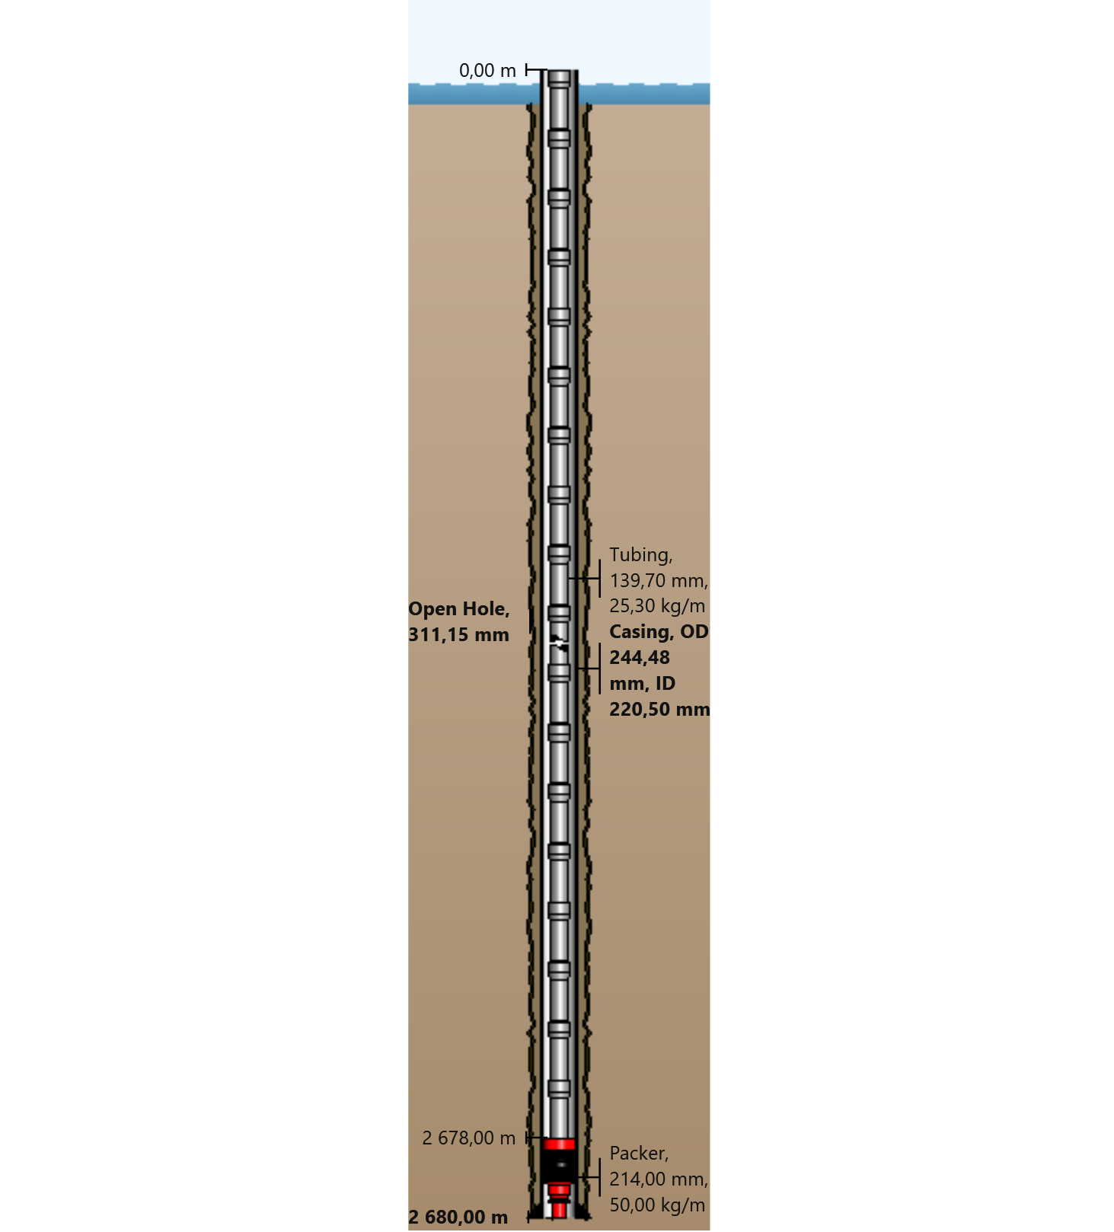

General Outputs Plots
  - Vertical Section
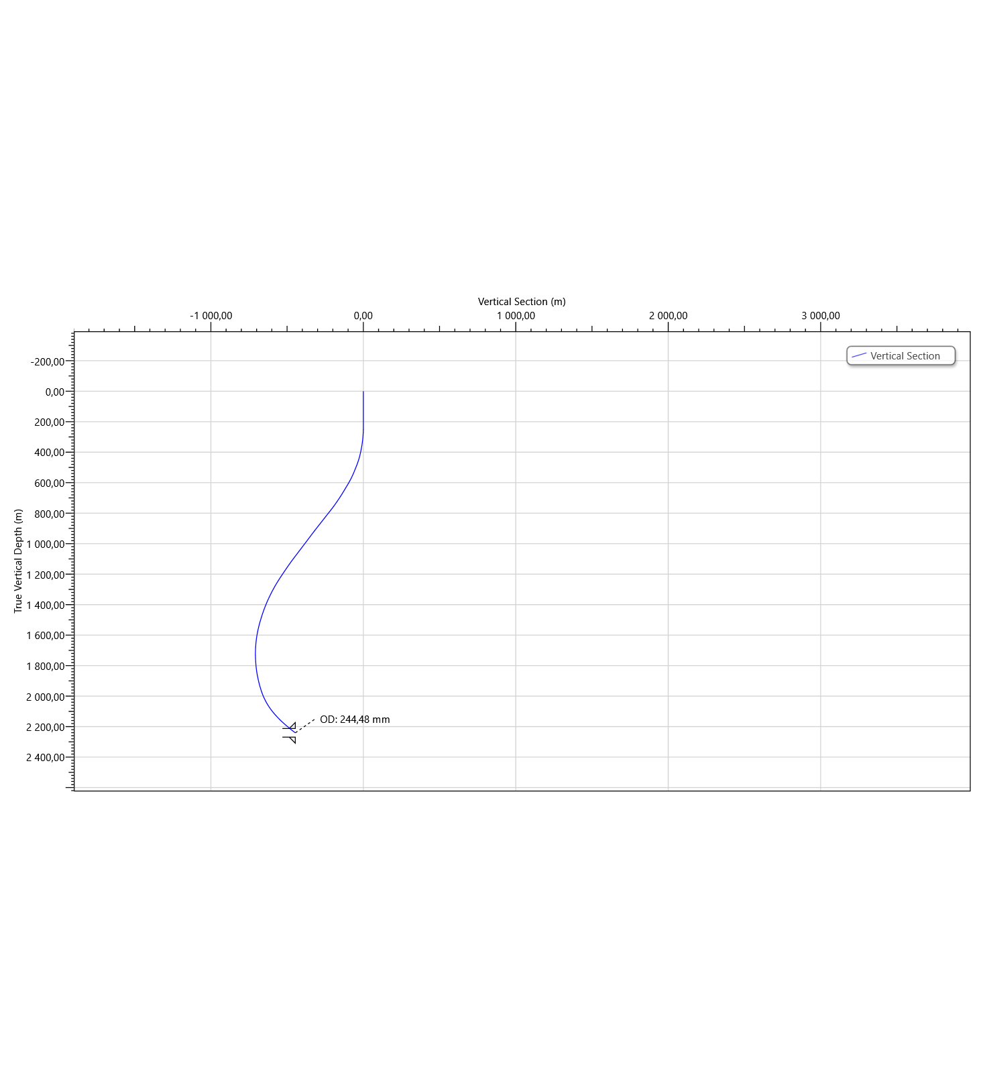
  - Plan View
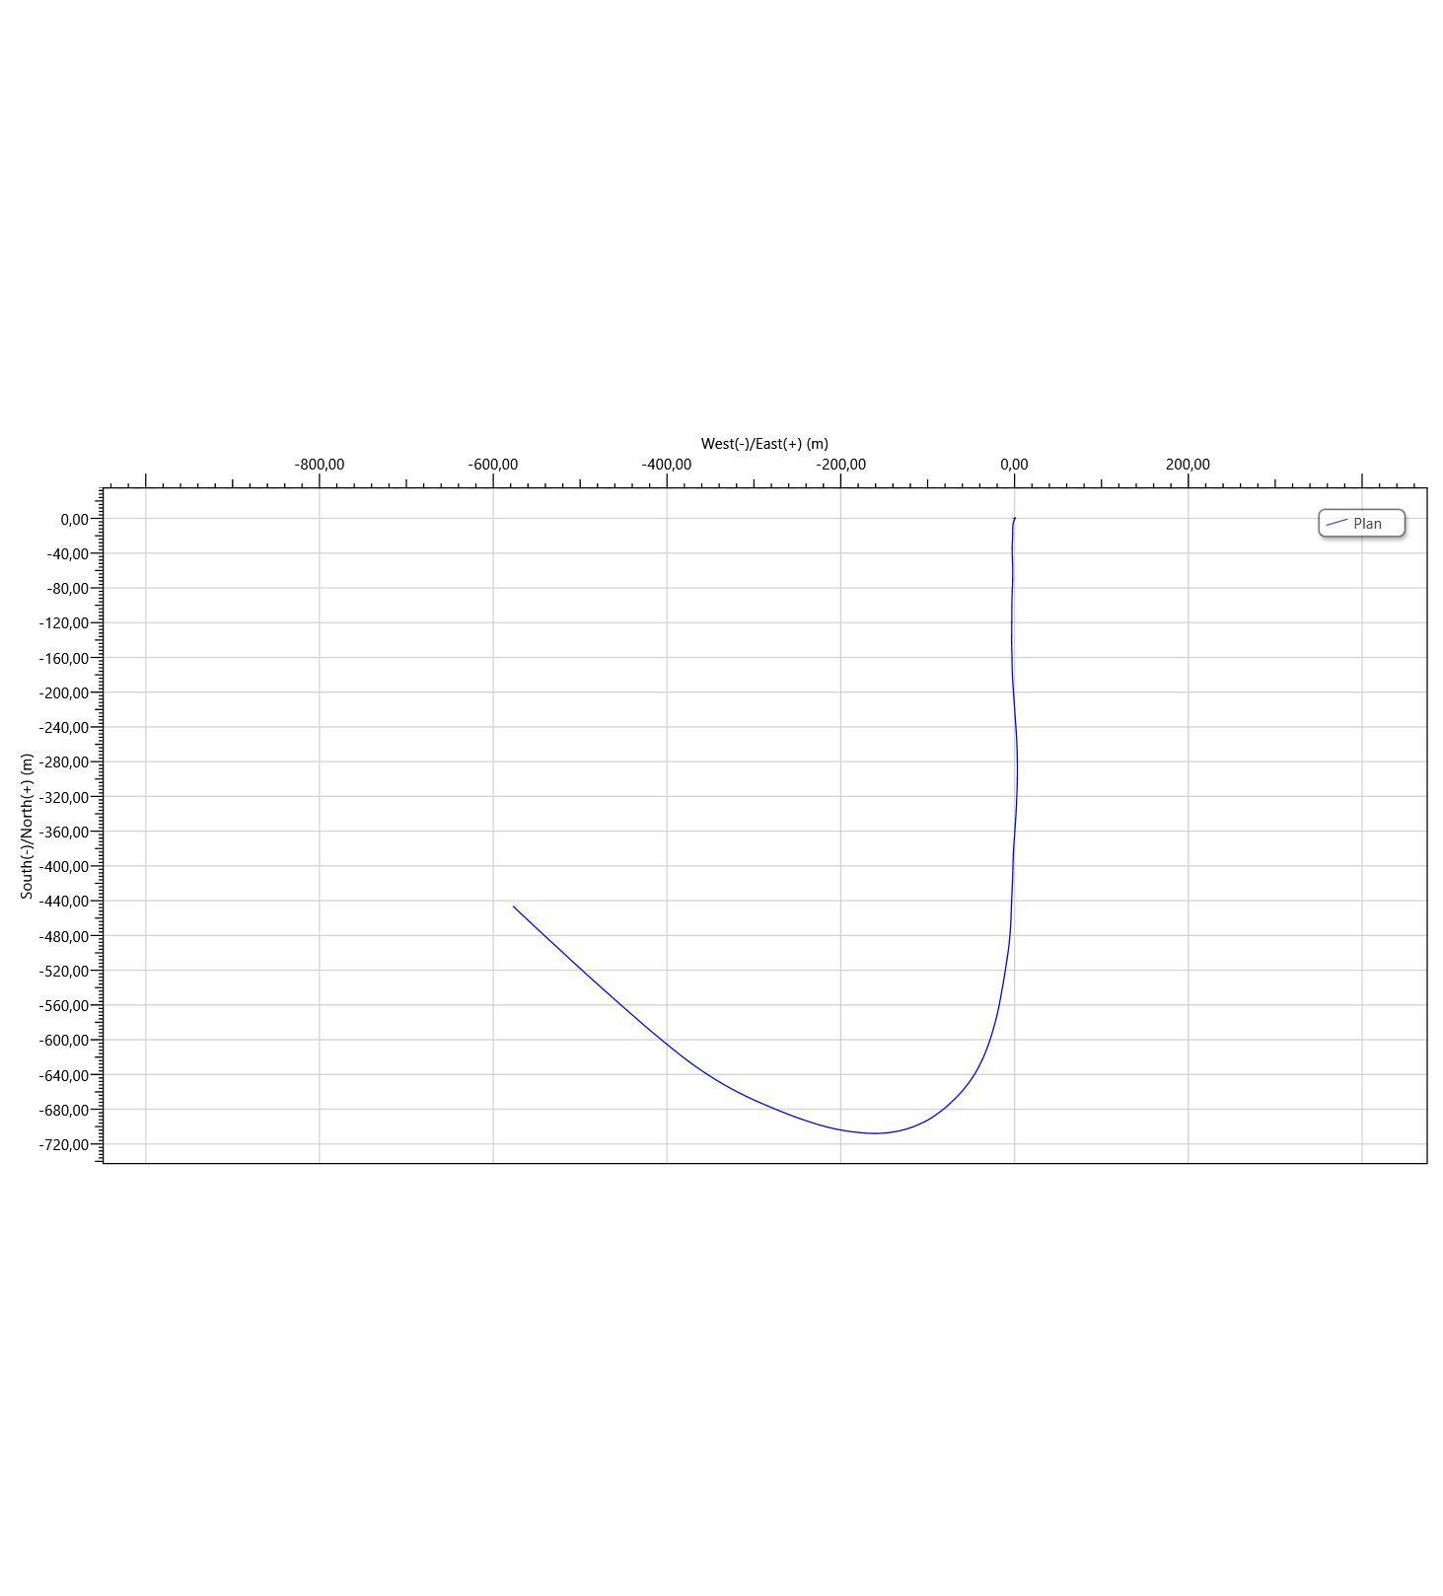

Torque & Drag Setup Data
  - Settings
Measured Depth of Bit | 2680,00 m | Bending Stress Magnification | No
Block Weight | 0,00 tonne | Stiff String Analysis | No
Enable Sheave Friction Correction | No | Viscous Torque and Drag | No
Pump Rate | 0,0000 m³/min | Contact Force Normalization Length | 9,45 m
Mechanical Efficiency (Single Sheave) | 97,00 | Lines Strung | 12
 |  | Side Force | N
Offset from Wellhead | m | Angle at Wellhead | °
  - Run Parameters
Start MD | 0,00 m | End MD | 2680,00 m
Step Size | 30,00 m
  - Normal Analysis Operational Parameters
Drilling | WOP/Overpull  (tonne) | Torque at Bit  (N-m)
Rotating On Bottom | NA | NA
Slide Drilling | NA | NA
Backreaming | NA | NA
Rotating Off Bottom
Tripping | Speed  (m/min) | RPM  (rpm)
Tripping In | 10,00 | 0
Tripping Out | 10,00 | 0
  - Friction Factors
Section Type | Coefficient of Friction
Casing | 0,23

  - String Fill Up
Use String Fill Up (Tripping In only) | No | Period | 0,00 m

Torque and Drag Results
  - Mechanical Limitations
Overpull Margin during a Tripping Out operation | 108,27 tonne | using | 100,00% of yield
Minimum Weight on Bit to Sinusoidal Buckle during a rotating on bottom operation | 18,92 tonne | at | 2678,00 m
Minimum Weight on Bit to Helical Buckle during a rotating on bottom operation | 26,56 tonne | at | 2580,62 m
Pick-Up Drag | 17,85 tonne
Slack-Off Drag | 12,25 tonne
Block Rating (Hoisting System) | tonne
Torque Rating (Rotating Equipment) | N-m
  - Load Summary
Load Condition | Stress Failure |  |  | Buckling Limits |  |  | Torque Failure | Torque at the Rotary Table  (N-m) | Total Windup with Bit Torque  (revs) | Total Windup without Bit Torque  (revs) | Measured Weight  (tonne) | Total Stretch  (m) | Axial Stress = 0 |  | Neutral Point Distance from surface  (m) | Neutral Point Distance from Bit  (m)
 | Fatigue | 90% Yield | 100% Yield | Sinusoidal | Helical | Lockup |  |  |  |  |  |  | Distance from Surface  (m) | Distance from Bit  (m)
Tripping In |  |  |  |  |  |  |  | 0,0 | 0,0 | 0,0 | 38,62 | 1,57 | 2196,54 | 483,46 | 2680,00 | 0,00
Tripping Out |  |  |  |  |  |  |  | 0,0 | 0,0 | 0,0 | 68,72 | 2,05 | 2351,45 | 328,55 | 2680,00 | 0,00

Torque and Drag Plots
  - Effective Tension
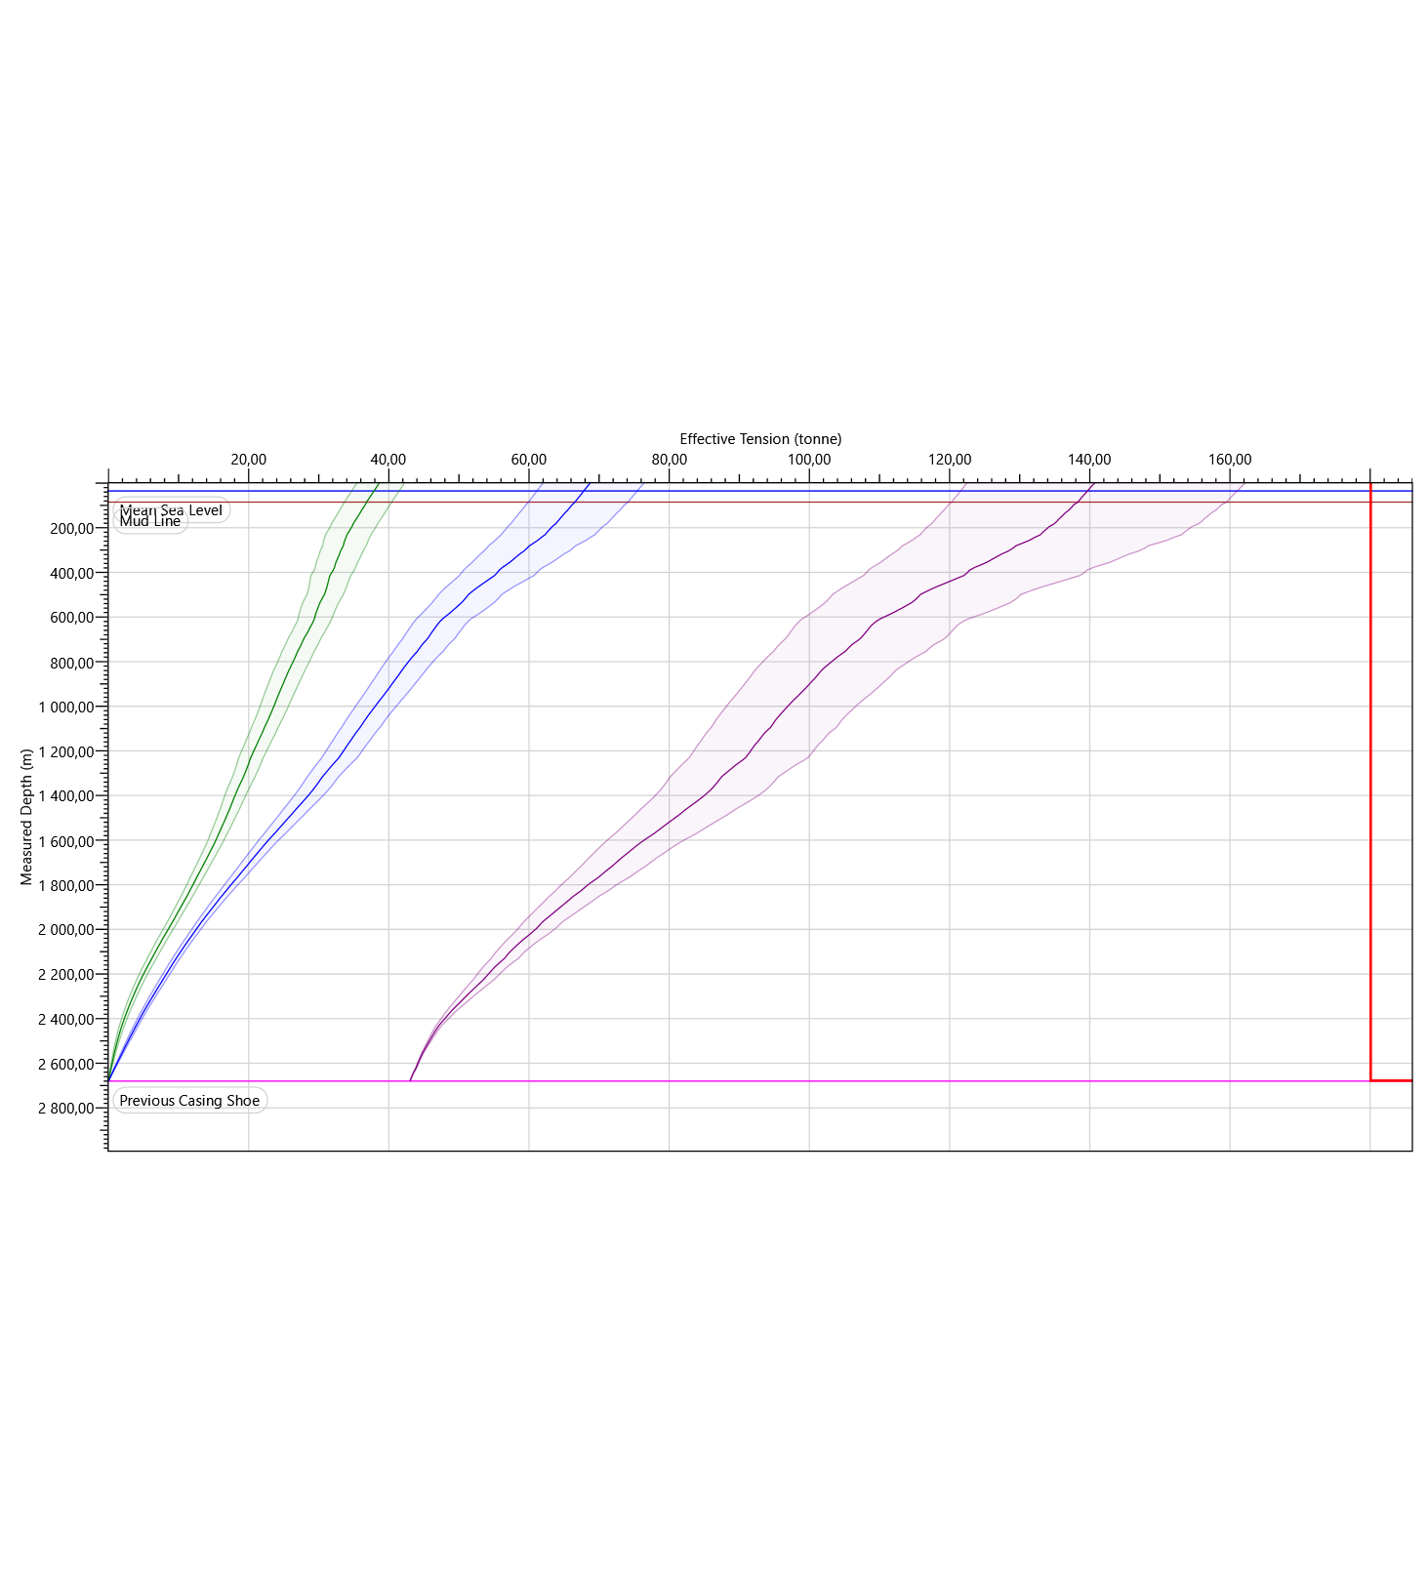
  - Hook Load
